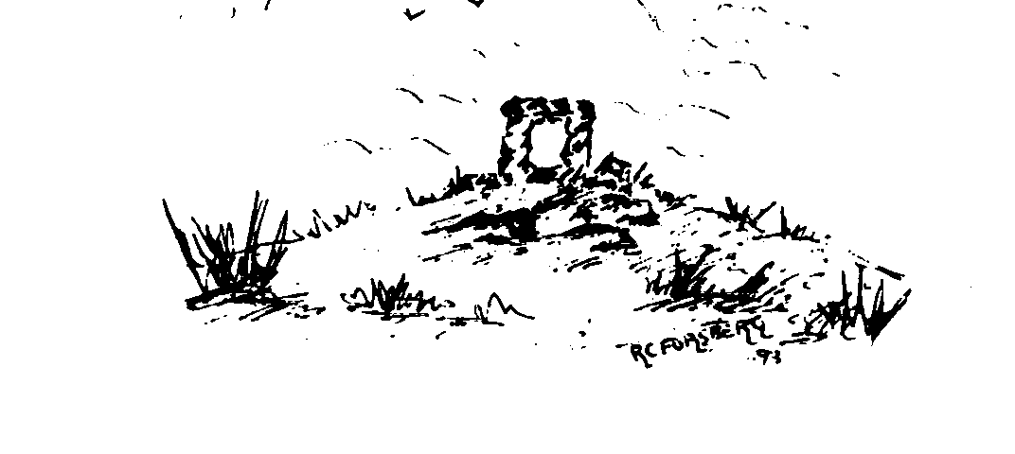
Insch Medical Practice

Dr Karen Simpson
Dr Paul J. Davies
Dr Kate Irvine
Dr Alison Steen
Dr Jessica Thomson
Dr Marc MacCrossan

Staff update Newsletter – September 2026

Dr Marc McCrossan
We are delighted to share that Dr Marc McCrossan has accepted an offer to become a Partner with the Practice. Dr MacCrossan joins the partnership from September 2026, working two days per week. This is excellent news for the Practice, and all our patients.

Dr Irvine and Dr Thomson
There have also been some changes to our established GPs working weeks:
- Dr Irvine has reduced to 3.5 days per week and will work every second Tuesday.
- Dr Thomson has increased to 4 days per week, working Monday to Thursday.

GP Specialist Registrars and Medical Student placements
- From August 2026 to February 2027, we welcome Dr Adedayo Aderoju (Dayo) as a GP specialist registrar – a qualified doctor training to become a GP.
- From February 2027 to August 2027, we will welcome Dr Muhammed Khairuddin Abd Khalid, also joining us as a GP specialist registrar – a qualified doctor training to become a GP.
.

University of Aberdeen – 4th Year Medical Students
In June, we welcomed our first 4th year medical student, in many years, to the Practice. We will continue to offer 5-week placements to students throughout this year and next.

We appreciate everyone’s continued support in helping our registrars and students gain the best possible experience during their placements.

We hope you will join us in welcoming all our new colleagues and learners to the Practice.

