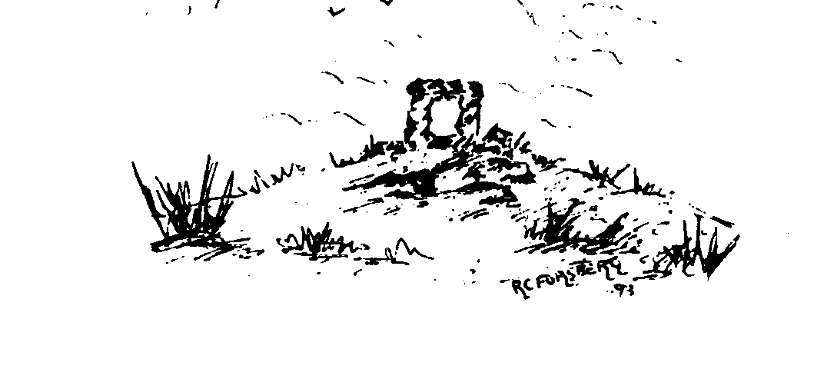
Insch Medical Practice

Dr Stephen J. Teale
Dr Karen Simpson
Dr Paul J. Davies
Dr Kate Irvine
Dr Alison Steen

Newsletter March 2023

Power outages
Following on from the power outage we experienced recently, we thought it would be helpful to let everyone know the services we can provide and how to access these services.

During a power outage we will be switched over to the hospital generator. This does not happen automatically, so we can have short periods of time when we too would be without power.
However, generally, we will be able to answer our telephones and conduct consultations as usual.

If you have a booked appointment and it is safe to do so, please attend. If you are unable to attend your booked appointment, please try to let us know, although we do understand that mobile phones and landlines can be affected by power cuts, so it is not always possible for you to communicate a cancellation to us.

GP Phone backs

Our GPs are experiencing a high volume of unanswered calls when trying to contact patients for pre booked telephone calls. This necessitates another call to be made and further time spent on reaching the patient.

It would be very helpful if you are expecting a telephone call from a GP if you:

- Ensure you phone is not set on silent mode.
- Ensure you do not block the line by phoning out.
- Note that calls from all NHS Grampian lines (not just Insch Medical Practice) no longer show as No caller ID or withheld – they all show the number 0300 373 0717.
- Please ensure your phone does not reject or block this number.

If you miss the first call, do not call the surgery, we will try once more. However, if the second call is missed you will be required to phone and rebook the appointment for a future date.

The reason we do not give exact callback times is to allow the GP to prioritise their calls from the details given by the patients and ensure the most time sensitive calls are returned first.

Brief indication of the reason you require a GP call or appointment

This leads nicely on to the reason why it is important that you accurately give details of your ailment to the reception staff. Comments like “private”, “ongoing” or “leg” will not assist the GP prioritising their calls and result in that call being the last to be returned.

Receptionists are bound by strict confidentiality policies and also trained to highlight red flag symptoms to the emergency GP. So before phoning us, think about what brief indication of symptoms you can give that will help the GP proiritise your call and be prepared to pass that information on to the receptionist.

Minor injury unit
When the Health and Social Care Partnership chose to close Insch Hospital, not only did we lose the inpatient services but we also lost the Minor injury service.
The triage of minor injuries is not a service covered by our GP contract and has always been provided locally by Insch Hospital nursing staff.
Access to this service is now through 111 who will direct you to the most appropriate location for your ailment.
The removal of this service was not a Practice decision. We would urge patients to follow the access instruction above and not walk into the surgery. We are sorry but we have neither the staff nor the facilities to deal with this type of unscheduled care.
If you wish to raise a concern about the lack of this service locally, we suggest you get in contact with NHSG Feedback Service, Summerfield House, 2 Eday Road, Aberdeen, AB15 6RE or gram.nhsgrampianfeedback@nhs.scot.

For your information the NHS define a minor injury as:
( in layman terms)
- Cuts capable of being closed by steristrips, gluing or minor stitching
- Minor dislocations or suspected fracture of fingers or toes
- Foreign bodies superficially embedded in tissues
- Recent injury (less than 48hrs ago) of a severity beyond simple domestic first aid
- Recent injury where it is suspected stitches may be
required
- Blows to the head where there has been no loss of consciousness
- Recent eye injury
- Small (not over 3cm diameter)partial thickness heat burns or scalds involving broken skin not involving the hands, feet, face, neck or genital areas
This is not an exhaustive list.

Text messages
For those of you already using our text messaging service, a point to remember:
All our text messages start with “GP no reply” this is to inform you that the text is from your GP and you cannot reply to the text – It does not mean we have been trying to contact you.
We use text messaging as it is a fast and effective way of contacting patients to highlight communications from the GP Practice, without the delay of using the postal service.
We will not send out sensitive information or results by text.
We often use texts to ask patients to contact the surgery if we have been unsuccessful in contacting you by telephone.
If you have a mobile number on record, we will use this as our preferred contact link, unless you tell us you would prefer we did not.

Polite reminder about prescription ordering timescales
Please remember that prescriptions have to be:
- Create
- Printed
- Checked and signed by a GP
- Delivered to the Pharmacist
- Scanned into pharmacy system
- Made up
- Labelled
- Packed
- Checked
BEFORE being ready for you to collect from the Chemist.
This is why we require 3 working days between you ordering your medications and you collecting them from the Chemist
Please ensure you are not leaving it too late to order your medications. We can not compromise our safety checks to compensate for your lack of planning

COVID19
Almost 3 years since we first encountered COVID 19, we are please to have been able to open up access to services which reflects the access we enjoyed pre-pandemic, with both face to face and telephone calls available to be pre-booked. We would highlight that we cannot book telephone calls for any ailment where you will need to be examined. All coughs, chest infections etc will necessitate a face to face appointment.

You may have noted we are not yet using the term ‘post’ pandemic as COVID19 is still prevalent in the Scottish population. Although many non health services have been able to move to a new normal, we have to comply with Scottish Government guidance and facemasks still require to be worn in all health care settings to protect both patients and staff from infection.
Thank you for your ongoing compliance and understanding of this necessary precaution.

